|  |  |
| --- | --- |
| Date | 25 June 2025 |
| Team ID | LTVIP2025TMID20412 |
| Project Name | Calculating Family Expenses using Service Now |
| Mentor Name | Dr Shaik Salma Begum |

# Calculating Family Expenses Using ServiceNow

**Introduction**

The *Calculating Family Expenses Using ServiceNow* project aims to build a centralized and scalable system for recording, categorizing, and managing household expenses. This solution enables families to track their daily and overall spending patterns, set budgets, and generate reports, thereby supporting better financial planning. The project leverages ServiceNow's platform capabilities to provide seamless integration of components, user-friendly forms, automated business logic, and scalability for families of varying sizes.

**Key Features**

* **Centralized expense tracking** at both family and daily levels.
* **Auto-numbering** of records with configurable prefixes (e.g., MFE for Family Expenses, DFE for Daily Expenses).
* **Custom forms** for streamlined data entry and validation.
* **Related lists** to view associated daily expenses under family records.
* **Business rules** to automate actions during record creation and updates.
* **Dynamic queries** to refine related list data based on relationships.
* **Scalability** to handle varying financial complexities and household sizes.
* **Compatibility with update sets** for easy migration or versioning of configurations.

**Pre-requisites**

* Active **ServiceNow Personal Developer Instance (PDI)** obtained from [developer.servicenow.com](https://developer.servicenow.com).
* Basic familiarity with:
  + **ServiceNow navigation and configuration**
  + **Tables, forms, and related lists**
  + **Business rules and Flow Designer**
* GitHub or other repository (optional) for maintaining documentation and exported update sets.

**Requirements**

**Functional Requirements**

* Create and manage family-level expense records.
* Create and manage daily expense entries linked to a family record.
* Auto-generate record numbers with prefixes for both tables.
* Display related daily expenses within the family expense form.
* Automate actions via business rules during insert/update operations.
* Enable reporting through ServiceNow capabilities.

**Non-Functional Requirements**

* Ensure ease of use through intuitive forms and layouts.
* Maintain data integrity between related records.
* Design for scalability to accommodate more records or families over time.

**Phases of the Project**

**Ideation Phase**

The project was conceptualized as a family expense tracking solution using ServiceNow. The goal was to empower users to record and monitor expenses at both daily and family levels, and facilitate better financial management through an integrated system.

**Requirement Analysis Phase**

* Identified two key tables:
  + **Family Expenses**: For overall household expense summaries.
  + **Daily Expenses**: For individual daily spending entries linked to a family record.
* Defined the relationship: Daily Expenses linked to Family Expenses.
* Selected features:
  + Auto-numbering with custom prefixes (MFE, DFE)
  + Custom forms for better data entry
  + Related lists for visibility of linked data
  + Business rules for automation
* Chose ServiceNow components: Tables, Form Designer, Number Maintenance, Relationships, Business Rules.

**Project Planning Phase**

The team executed these milestones:

1. ServiceNow Instance Setup
   * Signed up at developer.servicenow.com and requested a Personal Developer Instance (PDI)
   * Filled necessary details; received instance access credentials via email
   * Logged in and prepared the instance for development
2. Creation of New Update Set
   * Navigated to Local Update Sets and created a new update set named *Family Expenses*
   * Submitted and made the update set current to track configurations

1. Creation of Family Expenses Table
   * Created the Family Expenses table under *Family Expenditure* menu
   * Configured number field for auto-numbering (dynamic default: Get Next Padded Number)
   * Set up Number Maintenance with prefix MFE
   * Customized form layout using Form Designer

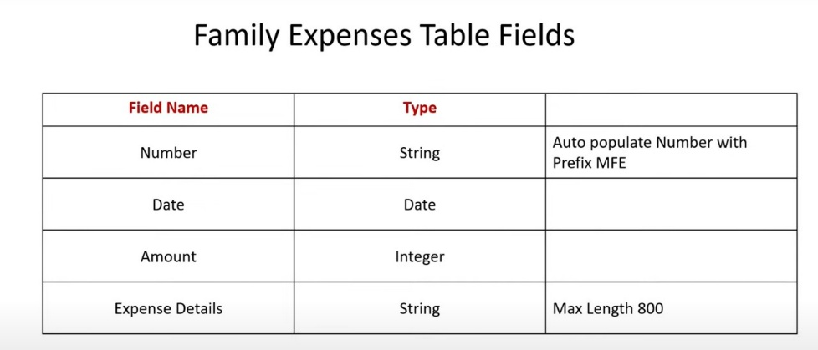

1. Creation of Daily Expenses Table
   * Created the Daily Expenses table under *Family Expenditure* menu
   * Configured number field for auto-numbering (dynamic default: Get Next Padded Number)
   * Set up Number Maintenance with prefix DFE
   * Customized form layout using Form Designer

**Project Design Phase**

The design phase focused on setting up relationships, related lists, and automation:

1. Creation of Relationship
   * Created relationship where Daily Expenses records are linked to Family Expenses
   * Configured queries so related list data aligns with the parent Family Expenses record

1. Related List Configuration
   * Added Daily Expenses as a related list within the Family Expenses form using the Configure Related Lists feature

1. Business Rule Creation
   * Created a business rule named *Family Expenses BR* on the Daily Expenses table
   * Enabled advanced options
   * Configured to trigger on Insert and Update actions
   * Implemented the logic to manage data consistency or automate actions (actual script written as part of development)

1. Final Relationship Configuration
   * Opened the previously created Daily Expenses relationship
   * Verified Applies to Table is set to Family Expenses
   * Entered and saved any dynamic query script to refine related list output

**Performance Testing**

* Tested record creation for both tables.

* Verified auto-numbering with correct prefixes.

* Checked related list accuracy for displaying linked records.
* Validated business rule execution on insert/update.

* Reviewed form design for clarity and ease of use.

* Confirmed data linkage integrity across tables.

**Conclusion**

The *Calculating Family Expenses Using ServiceNow* project delivers an effective solution for managing household financial data. By centralizing expense tracking and leveraging automation, the system ensures accuracy, transparency, and ease of use. The project demonstrates how ServiceNow can be adapted beyond enterprise IT to support real-world household applications, providing families with a tool to make informed financial decisions and maintain control over their budgets.